General Education Individual Course Submission Template
Please name the file with course prefix and number (i.e. ART 2209) and send as an email attachment to: gecourses@share.calstate.edu
Jump to Review and Approval Cycle

Course Information*
Complete for all courses
Course Prefix | Course Number | Course Title | Faculty Contact
SCI | 3209 | Computers & Society | Name Steve Garcia  Phone  Email steve@cs.csubak.edu
General Education Course Type
Please SEE TABLE BELOW if the [selection fields] do not work when this template is downloaded.
Course Type (select one from drop-down): | Upper-division B (Natural Sciences)
If applicable, choose a Thematic Course from these options: | Theme R: Revolutionary Ideas & Innovations
If applicable, choose a Concurrent Skill Connection from these options: | [Concurrent Skill Connection]
If applicable, choose a first Skill Reinforcement from these options: | Quantitative Reasoning (B4 prereq.)
If applicable, choose second Skill Reinforcement from these options: | Writing (A2 prereq.)
If applicable, choose from these options: | [Other]
TIP: If the [selection fields] break, please type in the selection from the choices listed below.
Course Type | Thematic Course | Concurrent Skill Connection |  | Skill Reinforcement 1
- A1 (Oral Communication)  - A2 (Written Communication)  - A3 (Critical Thinking)  - B4 (Math/Quantitative Reasoning)  - B1 (Physical Science)  - B2 (Life Science)  - C1 (Arts)  - C2 (Humanities)  - D (Social Sciences)  - AI-Hist  - AI-Govt  - Junior-Year Diversity Reflection  - Upper-division B (Natural Sciences)  - Upper-division C (Arts and Humanities)  - Upper-division D (Social Sciences)  - Capstone  - (none of the above/major) | - Theme Q: Quality of Life  - Theme R: Revolutionary Ideas & Innovations  - Theme S: Social & Environmental Justice | - A1 Co-requisite  - A2 Co-requisite  - A3 Co-requisite  - B4 Co-requisite |  | - Oral Communication (A1 prereq.)  - Writing (A2 prereq.)  - Critical Thinking (A3 prereq.)  - Quantitative Reasoning (B4 prereq.)
 | Skill Reinforcement 2 | Other
 | - Oral Communication (A1 prereq.)  - Writing (A2 prereq.)  - Critical Thinking (A3 prereq.)  - Quantitative Reasoning (B4 prereq.) | - SELF  - GWAR  - Large-format, lecture course

Does the Course Meet the SLOs and Course Requirements?
Provide a one-page ( maximum ) narrative describing how the components of the course you propose meets the relevant General Education learning outcomes and course requirements.
Rationale | See attached syllabus
Attach Syllabus
Attach the syllabus below using the Tip Sheet for Attaching a File. Alternatively, you may type the course information directly into Appendix A.
Insert > Object > Attach as File.
>
SCI 3209 Computers & Society
Catalog Description
SCI 3209 Computers & Society (3)
This course will provide a framework for examining the social context and consequences of information technology. Society, social change, and effects on the individual related to the use of computers will be the major concentrations. Emphases will include values, ethics, patterns, future directions, and relevant theories related to these phenomena.
Prerequisites by Topic
Students must have satisfied their A2 requirement before taking courses that reinforce writing skills.
Students must have satisfied their B4 requirement before taking courses that reinforce quantitiative reasoning.
Units and Contact Time
3 semester units. 3 units lecture (150 minutes)
Type
Satisfies upper division general education requirement for area B for the theme Revolutionary Ideas and Innovations.
Required Textbook
A Gift of Fire, 4th edition, Sara Baase, Pearson, 2013, ISBN-13 978-0-13-249267-6
Recommended Textbook and Other Supplemental Materials
None
Coordinator(s)
Steve Garcia
Student Learning Outcomes
Goal TR-1: Students will be able to identify and critically evaluate major consequences and implications of a revolutionary idea or innovation. Revolutionary ideas may be economic, social, ethical, cultural, political, and/or scientific, among others.
Outcome TR-1A: Students will identify the major consequences and implications of a revolutionary idea or innovation.
Outcome TR-1B: Students will critically evaluate the major consequences and implications of a revolutionary idea or innovation.
Goal 1: Students will demonstrate proficiency in quantitative reasoning.
Outcome QR-1A: Students will correctly utilize mathematical calculations and estimation skills.
Outcome QR-1B: Students will demonstrate quantitative reasoning skills.
Outcome QR-1C: Students will successfully apply quantitative reasoning skills to the real world.
Goal 2: Students will demonstrate proficiency in written communication.
Outcome WR-1A: Students will create proficient thesis statements.
Outcome WR-1B: Students will use discourse-appropriate syntax.
Outcome WR-1C: Students will use logical reasoning, at the appropriate level, to develop a text.
Outcome WR-1D: Students will use logical reasoning, at the appropriate level, to develop and organize ideas.
ABET Outcome Coverage
Not applicable to this course.
Lecture Topics and Rough Schedule
Chapter 1 | Ethics | Week 1 and 2
Chapter 1 | History and Concepts | Week 3
Chapter 3 | Free Speech | Week 4 and 5
Chapter 4 | Intellectual Property | Week 5 and 6
Chapter 2 | Privacy | Week 6 to 8
Chapter 5 | Crime | Week 9 and 10
Chapter 8 | Errors, failure, risk | Week 11 and 12
Chapter 6 | Employment and economics | Week 12 and 13
Chapter 7 | The future | Week 14 and 15
Design Content Description
Not applicable to this course.
Prepared By
Steve Garcia on July 30 2014
Approval
Approved by CEE/CS Department on [date]
Effective [term]

Review and Approval Cycle
This form represents the information necessary only for the additional GE approvals. The course must receive department approval before submission for GE. If the course carries a school prefix, it must be approved by the corresponding school curriculum committee. School approvals may proceed in parallel and require a different template. Select “GECCo Review” from the following drop-down field that represents the GE review/approval cycle.
Select Review and Approval Cycle: GECCo Review
Reviewers
Please enter the name of who is conducting the review for each step of the review cycle.
Review Cycle | Name | Date Complete | Comments / Revision Requests
GECCo | [GECCO Chair] | [GECCO Review Date]
AVP-AP (Final Approval} | [AVP_AP Name] | [AVP-AP Approval Date]

Appendix A: GE Syllabus Template
Dept xxx8/xxx9: [Course Title]
Instructor(s) [Name (s)]
Contact Information [email]
[office]
(661) 654-xxxx
Meeting Times TBA
Office Hours TBA
Textbook/Course Materials [enter default textbook(s) and/or other default course materials]
General Education This course meets the [enter GE requirement(s) this course will meet] requirement(s) of the CSU Bakersfield General Education Program including applicable themes and foundational skills.
Course Information
[enter course description here]
Course Student Learning Outcomes:
[enter the specific course Student Learning Outcomes this course intends to meet]
General Education Student Learning Outcomes:
[enter all General Education Student Learning Outcomes this course intends to meet]
Classroom Participation and Attendance
[enter policy and requirements here]
Assignments, Quizzes and/or Exams
[enter policy and requirements here]
Grading
[enter policy, requirements and percentages here]
Missed Assignments, Quizzes and/or Exams Policy
[enter policy here]

Lecture Schedule (add Laboratory schedule if applicable)
Week | Topic/Assignment/Activity/Discussion | Course SLO addressed (enter number from list above) | GE SLOs addressed* (enter number from list above)
1
2
3
4
5
6
7
8
9
10
11
12
13
14
15
16 | Final/Final Assignment
*Not all Topic/Assignment/Activity/Discussion throughout the semester have to meet a GE learning outcome as long as the overall course meets the GE course approval guidelines.

Note: The details of what such an assignment/activity/discussion/topic should entail will be developed in the Skill Reinforcement Groups (SRGs) and Faculty Interest Groups (FIGs) related to the thematic area before being approved by GECCo. It is the expectation of GECCo that the faculty member proposing the course (or the faculty member teaching the course) will participate in the appropriate SRGs and/or FIG during the 2014/15 and/or 2015/16 academic year(s). Otherwise, the approval will be revoked. However, if you already have an idea for such an assignment/activity/discussion/topic, please enter it here.

Accommodation for Students with Disabilities
To request academic accommodations due to a disability, please contact the Office of Services for Students with Disabilities (SSD) as soon as possible. Their office is located in SA 140, and they may be reached at 661-654-3360 (voice) or 661-654-6288 (TDD). If you have an accommodations letter from the SSD Office documenting that you have a disability, please present the letter to me during my office hours as soon as possible so we can discuss the specific accommodations that you might need in this class. Further information on the SSD office and support services available to you can be found at http://www.csub.edu/UnivServices/SSD/.

The campus accessibility policy can be found here:
http://www.csub.edu/UnivServices/SSD/CampusAccessPolicy.pdf.
Policy on Academic Dishonesty
Students are expected to do all work assigned to them without unauthorized assistance and without giving unauthorized assistance. For the complete policy, see the university catalog.

The campus policy on Academic Dishonesty can also be found here:

http://www.csub.edu/osrr/Academic%20Integrity%20/

Tip Sheet
How to Upload Your GE Course Syllabus
Upload Your GE Course Syllabus
Hint: Make sure your Cursor is clicked in the correct place in this document, where we ask you to attach the syllabus before you complete these steps!
- Locate and click on the “Insert Tab”
- Locate and click on the down arrow next to the word “Object” . From the drop-down, select “Object”.
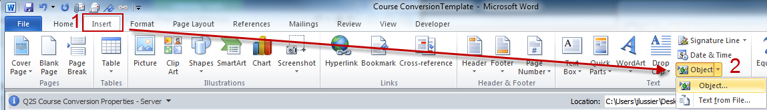
Selecting Object launches a dialog window (left screen)
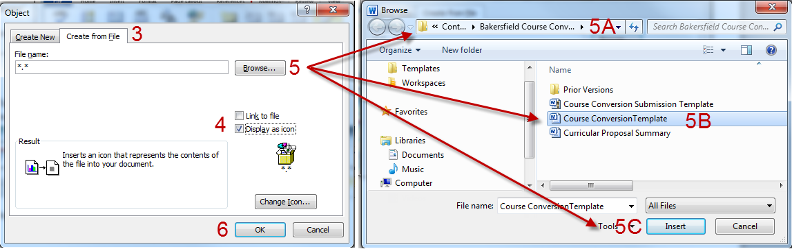
- Click the tab “Create From File”
- Select the checkbox “Display as Icon”
- Click “Browse” to launch the Browse dialogue box (right screen displayed above)
  - Use the top bar to navigate to where the course syllabus is located on your computer
  - Click on the filename
  - Click the “Insert” button
- You will be returned to the Insert Object screen, Click “OK” This will insert an icon of your course syllabus.

